Remembering Mark Murphy Quotes

Randy Brecker
"Nancy Kelly's tribute to Mark Murphy is wonderful remembrance and dedication to one of the jazz world's greatest vocalists. Each track brings something new to the table though...a heartfelt effort that I was proud to be a part of, having known/toured with Mark, and played on a couple of his albums."

Gary Walker, WBGO Music Director - NYC market:
"THANK YOU Nancy for making such a hip record.
It's a pleasure to share with the audience."

Eric Cohen, WAER Music director and 2-time award winning programmer of the year says:
" The CD is a Masterpiece "

Frank Wilner, WNHN FM 94.7 Concord, NH
" You have a winner here, very classy recording"

Mark Holston Jazziz “Nancy Kelly’s sense of phrasing is particularly arresting. She explores the nuances of lyrics as intently as a jeweler inspects a world-class gemstone.”

Joe Lang, Jersey Jazz "Remembering Mark Murphy is a spectacular recording ! Kelly shows the kind of individuality that was the hallmark of Murphy’s performances." -

Hot House Jazz NYC “Nancy’s 6th CD Remembering Mark Murphy, is exquisite.”

Peter Jones, author of the 2018 Biography,

This Is Hip: The Life of Mark Murphy had this to say about the CD.
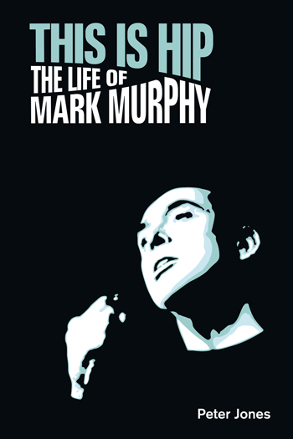
"This hip and mellow album
is far more than a tribute to
the great Mark Murphy;
it’s an outstanding contribution
to vocal jazz in its own right.
With her warm, sensuous voice,
Nancy Kelly has recorded sleek
contemporary interpretations
of the songs that formed such
an integral part of the Mark
Murphy repertoire."

Scott Elias, Freelance Film Producer and President at Random Acts Entertainment.
" The charts are all cool, and your PHRASING just slays me! It's like listening to Mark Murphy's hip kid sister, who is now a woman who shares his sensibilities, but has her OWN impeccable virtuosity and unique experiences to share."

London Jazznews . “Kelly has not merely reproduced Murphy’s versions of these tunes, but has given them a sleek, contemporary gloss. What makes this new album stand out from more routine tributes is the sheer quality of its arrangements and performances.

